Login Screen (will replace the image later)

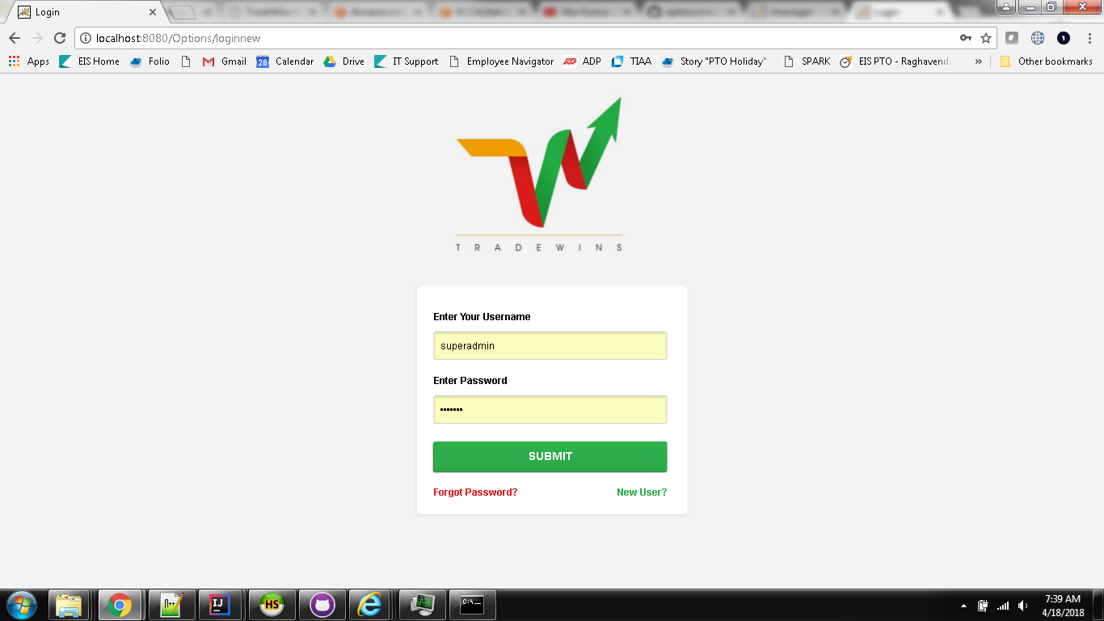

Welcome page of Super Admin (like us):

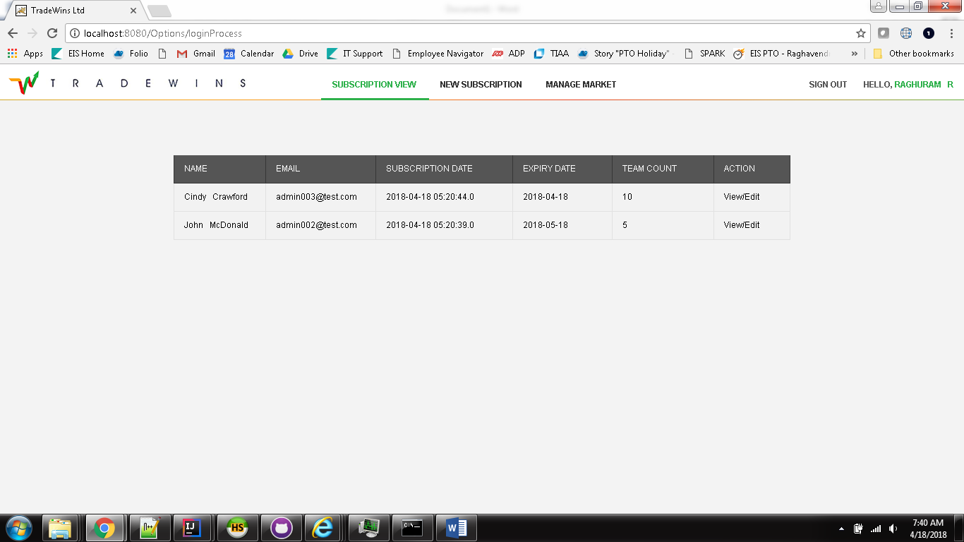

Click on View/Edit , following screen displays(broken into 2 screen shots):

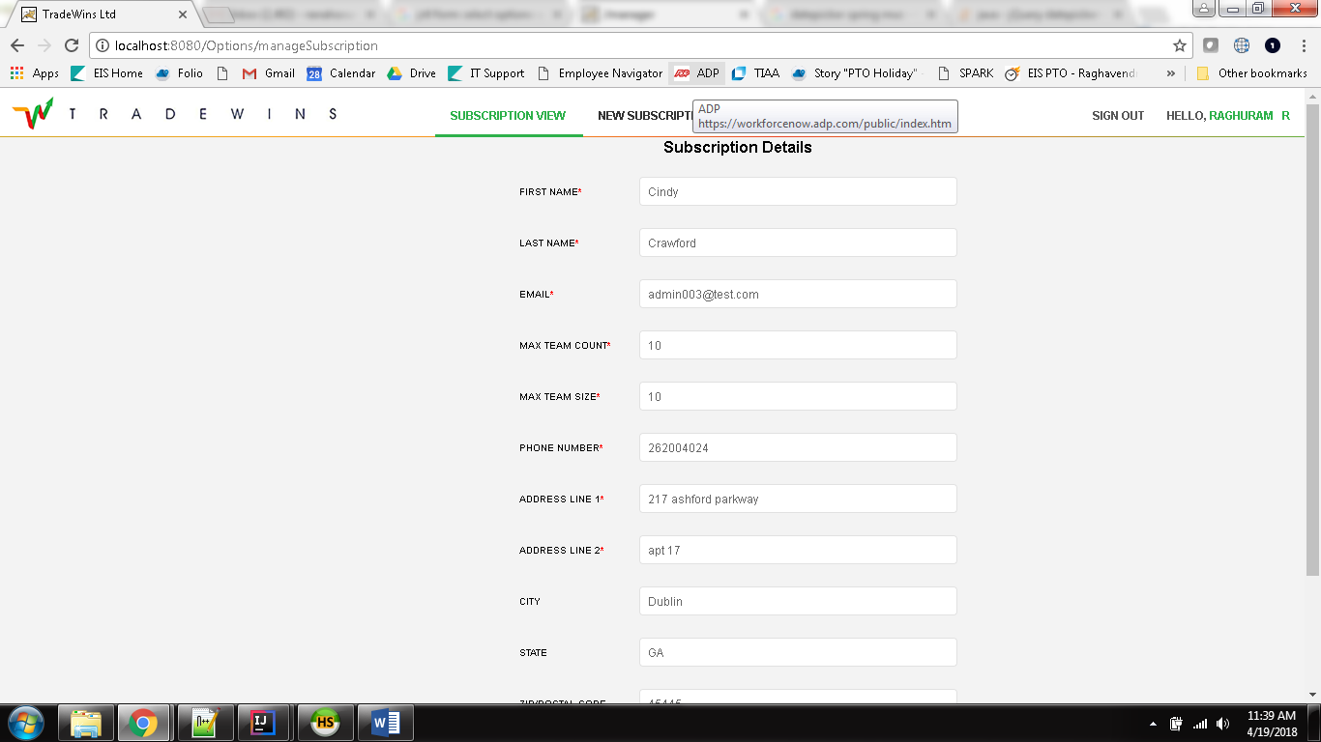

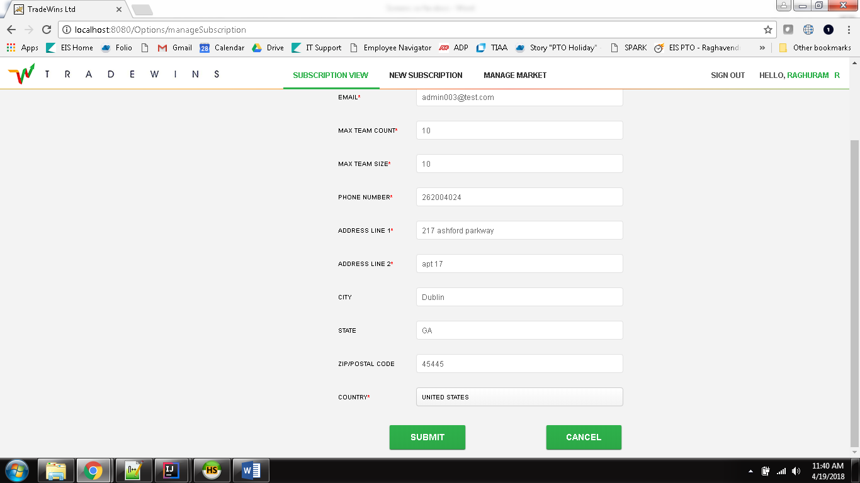

Clicking on Submit, saves and goes back to second screen (welcome).

Clicking on Cancel takes back to the welcome screen

Clicking on New Subscription results in following screen to add new subscription(broken into 2 screens including country dropdown):

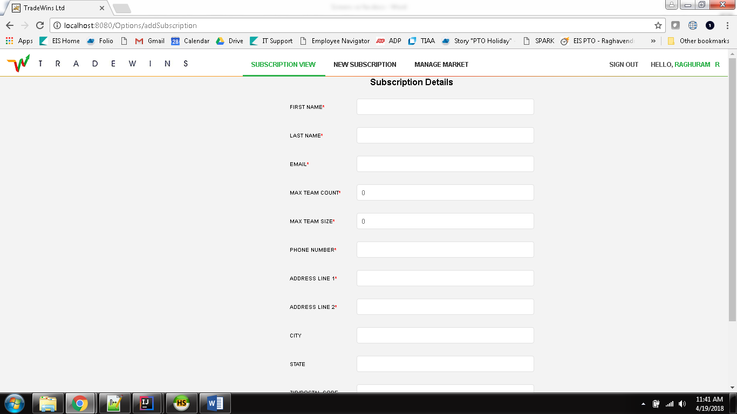

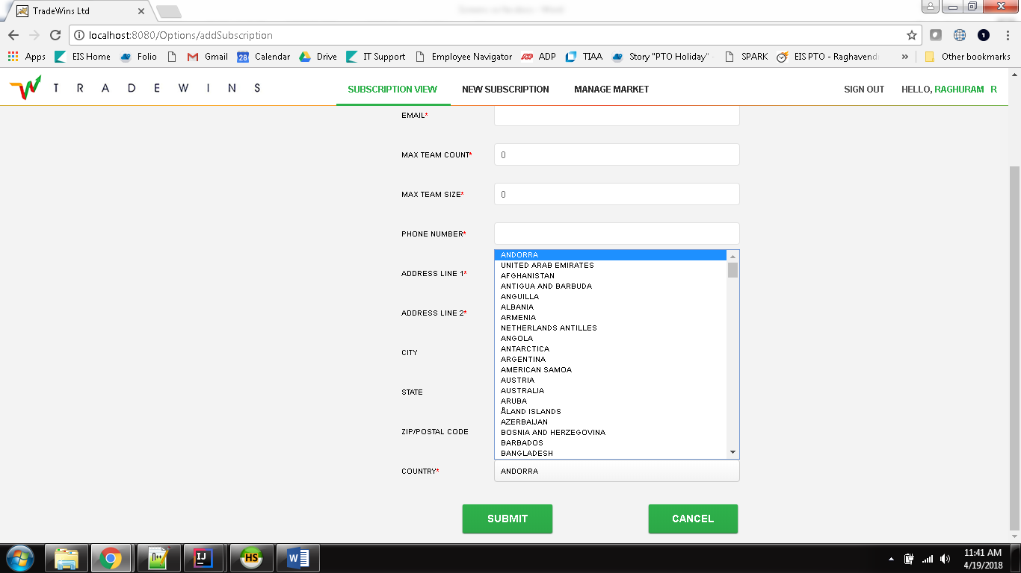

Submit and cancel behave the same way like the Edit screen.